# What’s Needed For Electric

* ArcGIS Data Interoperability Extension (using one of the following):
  + ArcGIS Pro 2.4, Utility Network Release 3 Version 3.2
  + ArcGIS Enterprise 10.7.1.
* Source Data
* [Electric Utility Network Configuration](https://solutions.arcgis.com/electric/help/electric-utility-network-configuration/)
* [Utility Network Package Tools](http://solutions.arcgis.com/utilities/help/utility-network-automation/)
  + Specifically: Electric Utility Network Data Loading: https://solutions.arcgis.com/electric/help/electric-utility-network-data-loading/get-started/overview.htm
* Electric Utility Network Migration Tools
* ArcGIS Enterprise 10.7 with ArcGIS Utility Network Management Extension

|  |  |
| --- | --- |
|  | * FME 2019.0.2.0 build 19260 can be used in place of the ArcGIS Data Interoperability Extension. |

# What’s Included

In the migration tools download you get the following:

* ArcGIS Data Interoperability / FME workspace (.FMW)
* Assembly Builder
  + Custom transformer that expands devices into assemblies
* Sample Microsoft Excel schema mapper file
* Sample source data
* Template Asset Package
* Additional rules spreadsheet

The included Template Asset Package provides additional rules and asset types which are not included in the current release of the Electric Utility Network Configuration. The additional rules and asset types included in the Template Asset Package are provided to illustrate a migration into an asset package that has been extended to

# Preparing to Migrate to the Utility Network

To facilitate a smooth migration to the utility network there should be pre-migration planning, validation, and if necessary data clean-up. Consistent and clean data reduces the likelihood of data migration errors when migrating to the utility network. Esri has provided [ArcGIS Data Reviewer checks](https://solutions.arcgis.com/utilities/electric/help/data-reviewer-for-electric-utilities/) that can be configured against the source data to identify data issues that need to be resolved prior to the migration.

Any errors identified by the ArcGIS Data Reviewer checks should be corrected prior to executing the migration tools to mitigate migration errors. Attention should also be given to the consistency of how related records are stored and managed. Related records should be consistently managed; for example, if a fuse point on an electric network is protecting all three phases, the related record should have three-unit records, one for each phase. It should not be also represented as one-unit record with all three phases.

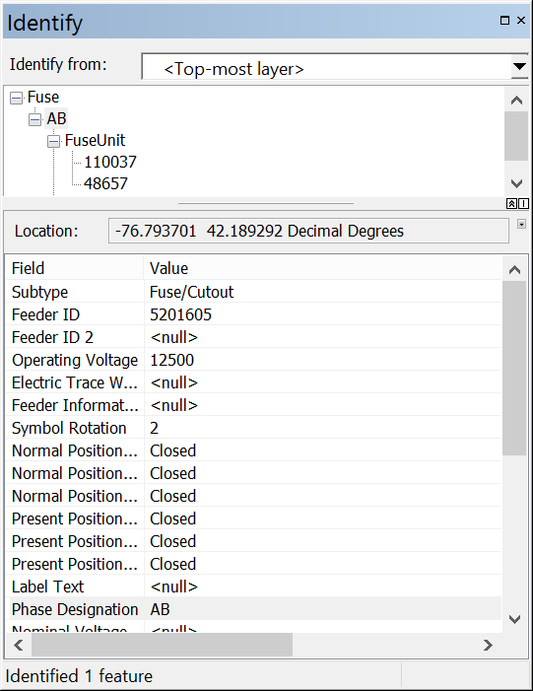 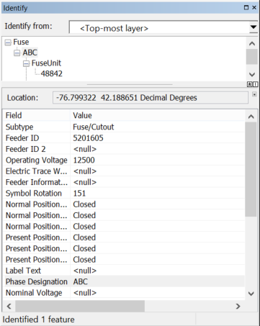

Some of the issues that cause issues, outside of rule violations, are:

* Stacked features (without Z value)
* Self-intersecting lines

# Utility Network Representation

The utility network has the capability to represent network assets in high fidelity, just like they are constructed in the real world. This is accomplished via the utility network information model and the domain specific data models that enable modeling of network relationships down to every terminal.

In planning to migrate to the utility network, you should consider the level of representation you will be migrating to. The granularity of how the data is represented in the target utility network can be categorized into three categories:

* Simple - data migrated in its current form from the geometric network
* Basic - includes modeling and representing the real world in a higher fidelity to support better analytics within and outside the GIS
* Advanced - a step beyond basic to support planning, design and extended modeling within the GIS

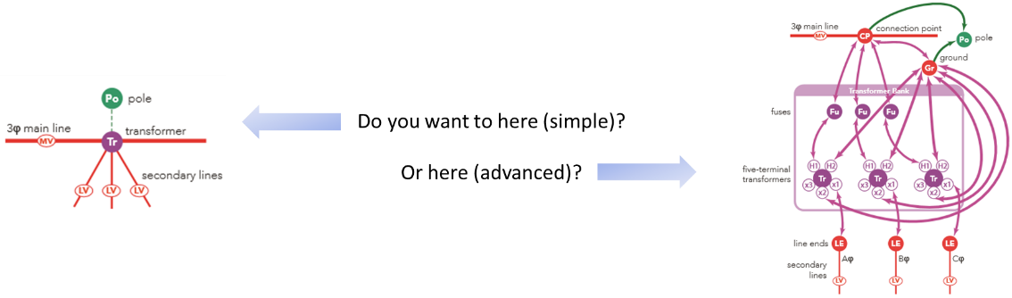

For example, you want to represent your transformer in a more detailed representation, rather than the single point that is in the current source data. Using the Assembly Builders, you can explode a single point and records in it’s unit tables into a complex configuration.

Please review the help documentation for the utility network for the benefits of a more detailed representation of your data with ArcGIS. General reasons include:

* Many of the other systems (ADMS, outage management, modeling packages, etc.) you exchange data with require the more advanced representation. By storing this representation in the GIS you can simplify the data exchange routines with the other systems.
* A more advanced representation in ArcGIS allows for more modeling to be done within the GIS.
* Better accounting of the devices you actually have in the field.

# Electric Utility Network Configuration

Esri has provided a series of tools to assist with the implementation of your utility network. It is recommended that these tools be used to stage the target utility network. In addition, these tools also support applying the asset package, which is the output of the migration workspace, to the utility network. Please refer to the [Utility Network Package Tools](http://solutions.arcgis.com/utilities/help/utility-network-automation/use/what-are-the-utility-network-package-tools.htm) for staging an environment for the output asset package.

Now that you have an understanding of migration representation options, it is now time to start with your electric distribution utility network configuration. The [help documentation](http://solutions.arcgis.com/electric/help/electric-utility-network-configuration/get-started/get-started-overview.htm) provides you with the steps to get you started with your implementation. Following this documentation, you will stop after you complete the “Stage utility network” step in the “Create an electric utility network”. We will continue where we left off later in this process.

# Asset Package

Once you have cleaned the source data and have an understanding of the innerworkings of all the assets in your source data, it is then time to review the target electric asset package. The target electric asset package is a representative configuration of a common data model as well as rules and other network properties for the target utility network. You should take time to familiarize yourself with the electric asset package so that you understand the feature classes, Asset Groups / Asset Types, attributes, rules and other properties. Gaining understanding of the target electric asset package will help with:

* How to map source features to the target asset package
* Identifying gaps between data elements in the source features against the electric asset package

The [Asset Package](http://solutions.arcgis.com/utilities/help/utility-network-automation/asset-package-reference/an-overview-of-the-asset-package.htm) is simply a way to model the components of a utility network.  Asset packages can be used to configure a utility network and as an interchange file to import and export the properties of a utility network.

Asset Packages are stored in a file geodatabase and can include the components that model a utility network as well as data to load into a utility network. The Electric Utility Network Migration Tools leverage asset packages for data loading.

It is important to understand that while asset packages can contain data and can be interacted with by ArcGIS clients, they are not an actual utility network.  They are used to configure and interchange data with a utility network.

An asset package is supplied with the Electric Utility Network Configuration that provides a common set of electric distribution and transmission network behavior to a utility network. Users can further refine this asset package to add additional attributes and/or network behavior.

The output of the Electric Utility Network Migration Tools is also an asset package that can be used to load data into a utility network. Because you will not load the sample data and will be loading your migrated data instead there are a few pre-processing steps that need to be performed in order to convert it to a template asset package that will be used by the migration workspace. The pre-processing steps are performed by the [Change Asset Package Spatial Reference tool](http://solutions.arcgis.com/utilities/help/utility-network-automation/tool-reference/change-asset-package-spatial-reference.htm) which is included with the Utility Network Package Tools. This tool updates the spatial reference of the Asset Package to your coordinate system and truncates the sample data in the Asset Package so you can load your own. The result output is the Asset Package Template that you will use in your parameter configuration when running your workspace.

For more information about the structure of the Asset Package see the [Asset Package Reference.](http://solutions.arcgis.com/utilities/help/utility-network-automation/asset-package-reference/an-overview-of-the-asset-package.htm)

# Schema Mapping Spreadsheet

Now that your source data has been cleaned and you have an understanding of the electric asset package, it is time to map your source data to the target electric asset package. This mapping is done with the schema mapping spreadsheet. The schema mapping spreadsheet is referenced by the SchemaMapper transformers in the migration workspace of the ArcGIS Data Interoperability extension or FME Workbench workspace file. The spreadsheet has several tabs that map the source ArcGIS schema to the target utility network schema. The information below is a guide to updating the schema mapping spreadsheet; in addition, the sample schema mapping spreadsheet has been populated with sample inputs from the published electric asset package as well as source mappings to the sample data that is provided with the migration tools.:

* **AssetGroups&Types:** defines the asset group and asset type mappings
* **Domains:** Defines source to target domain and subtype mappings
* **Feature Classes:** These tabs are used to map the source ArcGIS attributes to the target Utility Network attributes.

Limitations:

* ***Nulls****: Microsoft Excel does not handle true NULLs. In cases where a true NULL needs to be mapped to the target add “<Null>” to the cell.*
* ***Case****: the spreadsheets and FME are case sensitive, so ensure the case for attributes and values in the source and target mappings match the data you are working with.*
* ***Filters****: simple ‘and’ filters or joins are used in the spreadsheet to identify which row to use for the schema mapping. For example:*

*If ArcGISFeatureClass = wControlValve AND VALVETYPE = PC   
 then ASSETGROUP = 1 AND ASSETTYPE = 0*

*More complex logic for identifying mappings that might require AND, OR to formulate the mappings might need to be added to the workspace.*

|  |  |
| --- | --- |
|  | Users will have to review and update the schema mapping Microsoft Excel spreadsheet based on source data and target asset package schema. |

***AssetGroup&Type Tab*** *– Defines how the source data will map to the target FeatureClass.AssetGroup.AssetType*

* DomainNetworkName – defines the domain network name – usually Electric or Structure
* UNFeatureClass—defines the target feature class for the domain network and structure network
* AssetGroupCode —the coded value of the Asset Group
* assetGroupDesc—the description of the Asset Group that is presented for the coded value of the Asset Group
* assetTypeCode —the coded value of the Asset Type
* AssetTypeDesc —the description of the Asset Type that is presented for the coded value of the Asset Type
* ArcGISFeatureClass—defines the source feature class that supplies the data to the target FeatureClass.AssetGroup.AssetType
* Primary / Secondary / TertiaryAttrName—the field name where the Primary / Secondary / TertiaryAttrValue data is stored.
* Primary / Secondary / TertiaryAttrValue—fields that define simple “and” logic to source the data values for the target FeatureClass.AssetGroup.AssetType. At a minimum PrimaryAttrValue is required. Additional AttrValues are used when additional logic is required for example: Material = “ST” and Subtype = “2” maps to PipelineLine.Service Pipe.Unknown
* Columns that define the names of attribute values:
  + FeatureTypeAttr fme_feature_type
  + assetgroupAttr ASSETGROUP
  + assetTypeAttr ASSETTTYPE
  + assetGroupDescAttr ASSETGROUPDESC
  + assetTypeDescAttr ASSETTYPEDESC
  + UNFeatureClass _UNFEATURECLASS
  + DomainNetworkName _domainNetworkName

***Domains Tab****– Defines source to target domain and subtype mappings. This tab defines how the existing coded values in the source will be translated to the target asset package.*

* ArcGISFeatureClass—defines the source feature class that supplies the data to the target domain/subtype
* ArcGISAttrName—name of the field that stores the source data
* UNAttrName—name of the field that stores the target data
* ArcGISDesc—description of the coded value in the source database that is presented to users through ArcGIS user interfaces
* ArcGISCode—coded domain/subtype value stored in the source geodatabase
* UNDesc—description of the coded value in the utility network that is presented to users through ArcGIS user interfaces (used only for documentation and clarity)
* UNCode—coded domain/subtype value stored in the target utility network geodatabase
* FeatureTypeAttr - The variable that the schema mapper transformer in the workspace uses. This will always be: “fme_feature_type” for any mapped values.

***DomainsNominalVoltage –*** *defines the mapping of ArcGIS voltage domains to UN voltage & line-to-ground voltage domains*

* ArcGISFeatureClass – used if voltage is specific to a source data feature class (usually left blank)
* ArcGISAttrName – name of the source data voltage attribute. i.e. NOMINALVOLTAGE
* UNAttrName – name of the UN voltage attribute i.e. NOMINALVOLTAGE
* UNAttrNameLG – name of the line-to-ground voltage i.e. NOMINALVOLTAGELG
* ArcGISDec – source data domain description – used for documentation and clarity only
* ArcGISCode – domain code for the voltage
* UNDesc – UN data domain description – used for documentation and clarity only
* UNCode – domain code for the UN voltage attribute defined in UNAttrName
* UNCodeLG - domain code for the UN voltage attribute defined in UNAttrNameLG
* FeatureTypeAttr – if a feature type filter is used. Always fme_feature_type
* UNSystem - UN system description – used for documentation and clarity only

***LineToJunctionLookup –*** *lookup table used to define line end junction based on Line Asset Group / Type*

***Feature Class Tabs*** *– Attribute mapping: These tabs are used to map the source attributes to the target attributes. <Domain>Device, <Domain>Junction, <Domain>Line, StructureBoundary, StructureJunction, StructureLine.*

* UNAttrName—name of the source field that is being mapped to the target utility network
* ArcGISFeatureAttr—name of the target field that the source is being mapped to
* UNAttrDefaultValue—default value to be populated in the translation (if any)
* *Note: The following fields should be excluded in the mapping as they are managed by the workspace:*
* *GlobalID*
* *ShapeLength*
* *Assetgroup*
* *Assettype*

|  |  |
| --- | --- |
|  | * Fields that are domain fields should be excluded, or for clarity, flagged as a domain, i.e. LIFECYCLESTATUS <domain mapping>, since they will also appear in the Domains tab |

***ConductorInfo –*** *Attribute mapping - to map the source attributes to the target attributes.*

# Review the Migration Workspace

In addition to the documentation included here, the migration workspace has many documentation comments and bookmarks within it to support a successful configuration. Some of the comments within the workspace provide guidance on working around known issues:

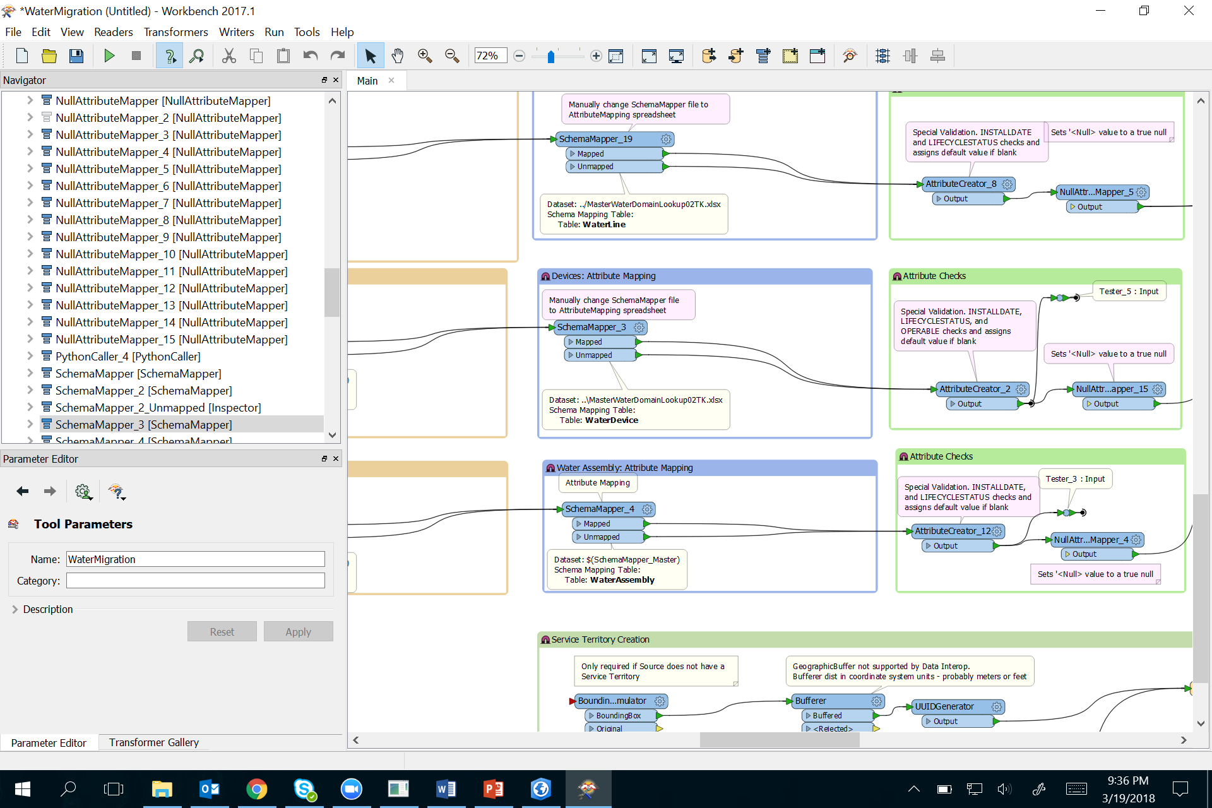

While others are tips to help with understanding what the workspace is doing, in case more advanced configuration is required:

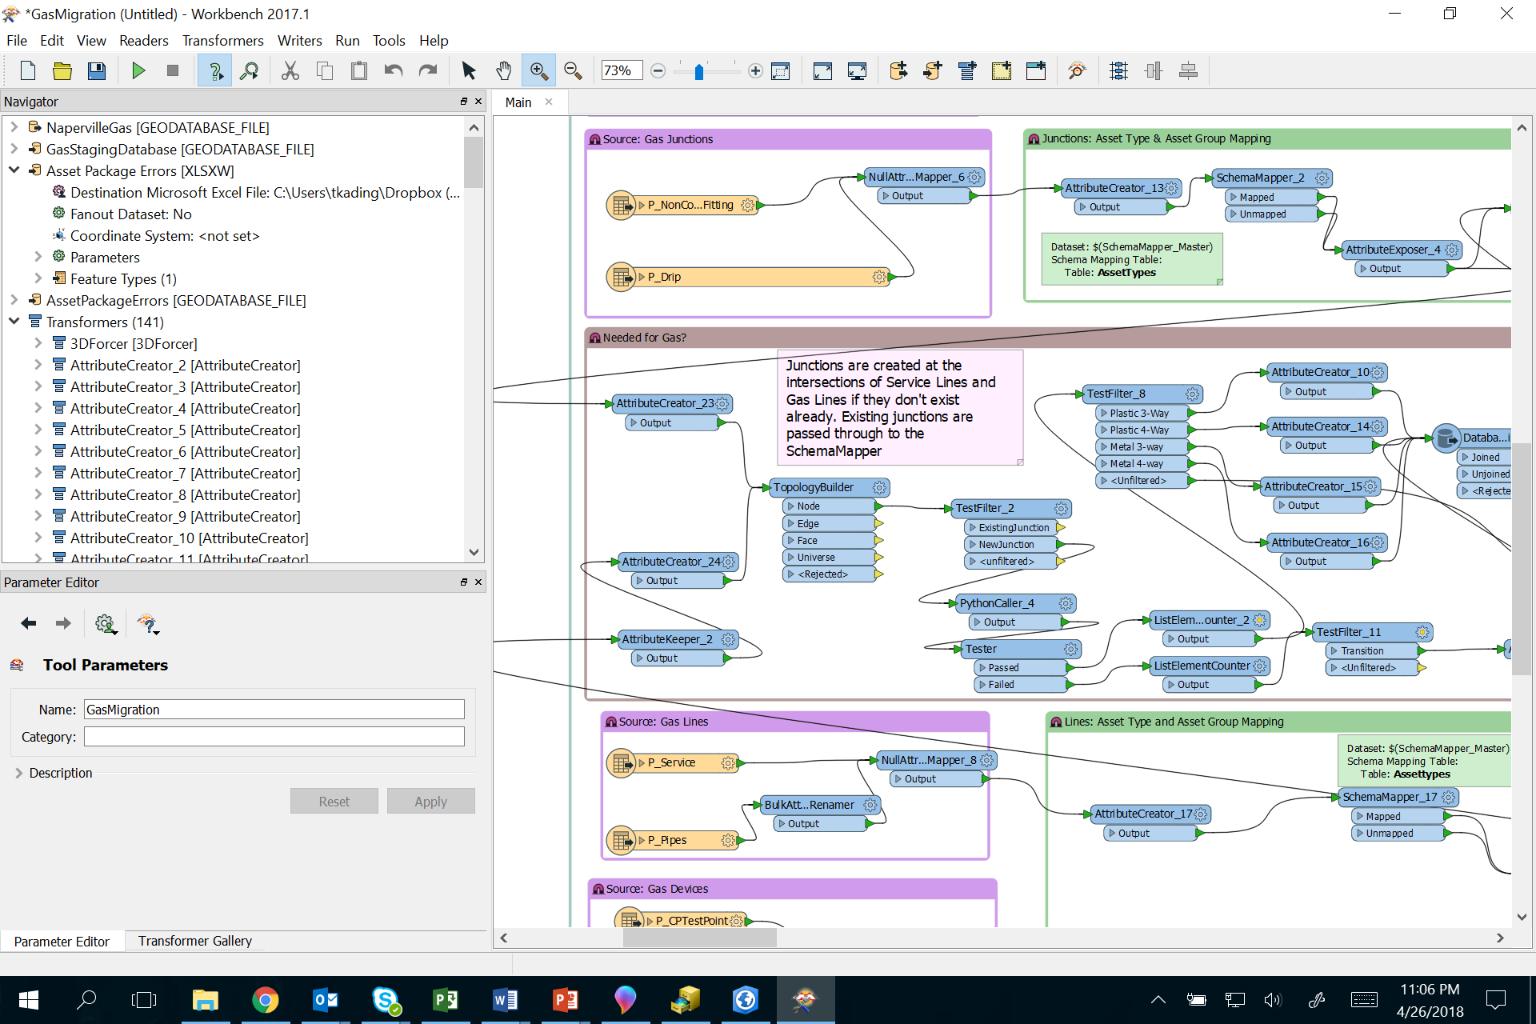

# Update Source Data Feature Types

Source data features will need to be updated in the migration workspace to support your source ArcGIS data model. In the “Readers” menu, select “Add Reader”.

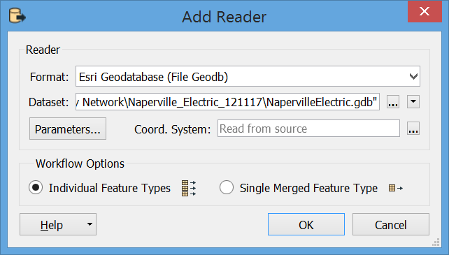

Define the type of source data in the “Format” dialog:

* File Geodatabase
* Enterprise Geodatabase
* Etc.

Then define the location of the source data in the “Dataset” dialog.

Once the source data has been defined, select “Parameters…” to define what source features will be added to the migration workspace.

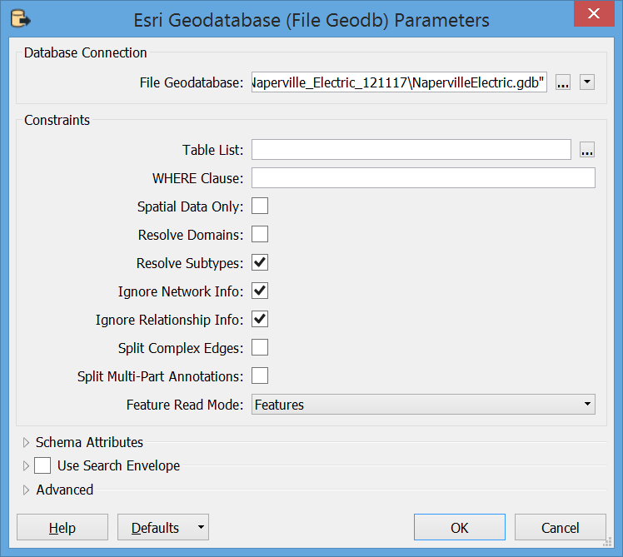

Select the “…” next to the “Table List” dialog, this will open a “Select Table List” dialog allowing the user to select the features that will be brought into the migration workspace.

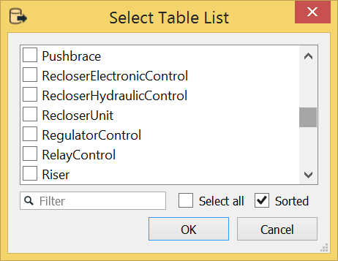

Select all the features that will be migrated to the asset package and select “OK”. Then select “OK” in the “Add Reader” dialog. This will bring your source features into the migration workspace. The added feature types will be added to the left-hand side of the workspace as individual feature records. These feature types will be brought in independent of any workspace migration transformers; in other words, they will not be connected to the proper SchemaMapper transformer. Once the added source features are added to the workspace, the user must then drag and drop the source feature arrow to the appropriate SchemaMapper transformer. Note: Existing sample source feature types should be disabled by right clicking on the sample source feature(s) and selecting “Disable”. You may need to iterate through the disabling of sample source features and the dragging and dropping of added source features to the appropriate SchemaMapper transformer to fully disable all sample features and map all added source features.

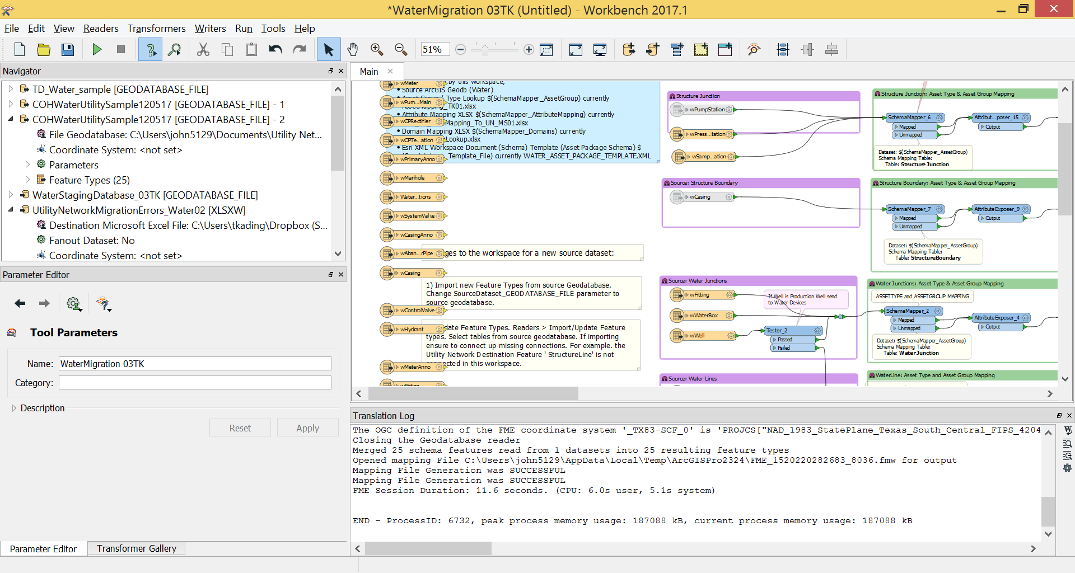

# Update Target Feature Types

Target feature types only need to be updated if there have been schema changes to the published asset package; for instance, if a new asset group / asset type has been added or a new attribute field has been added. There is a two-step process for updating the asset package being used in the workspace writer:

1. Change the Template Geodatabase—in the Navigator pane select the writer file geodatabase and double click the “File Geodatabase” to change the template. Once the dialog opens, point to the location of the modified asset package. By changing the template, all future runs of the migration tools will use the version of the modified asset package rather than the default version included with the migration tools.

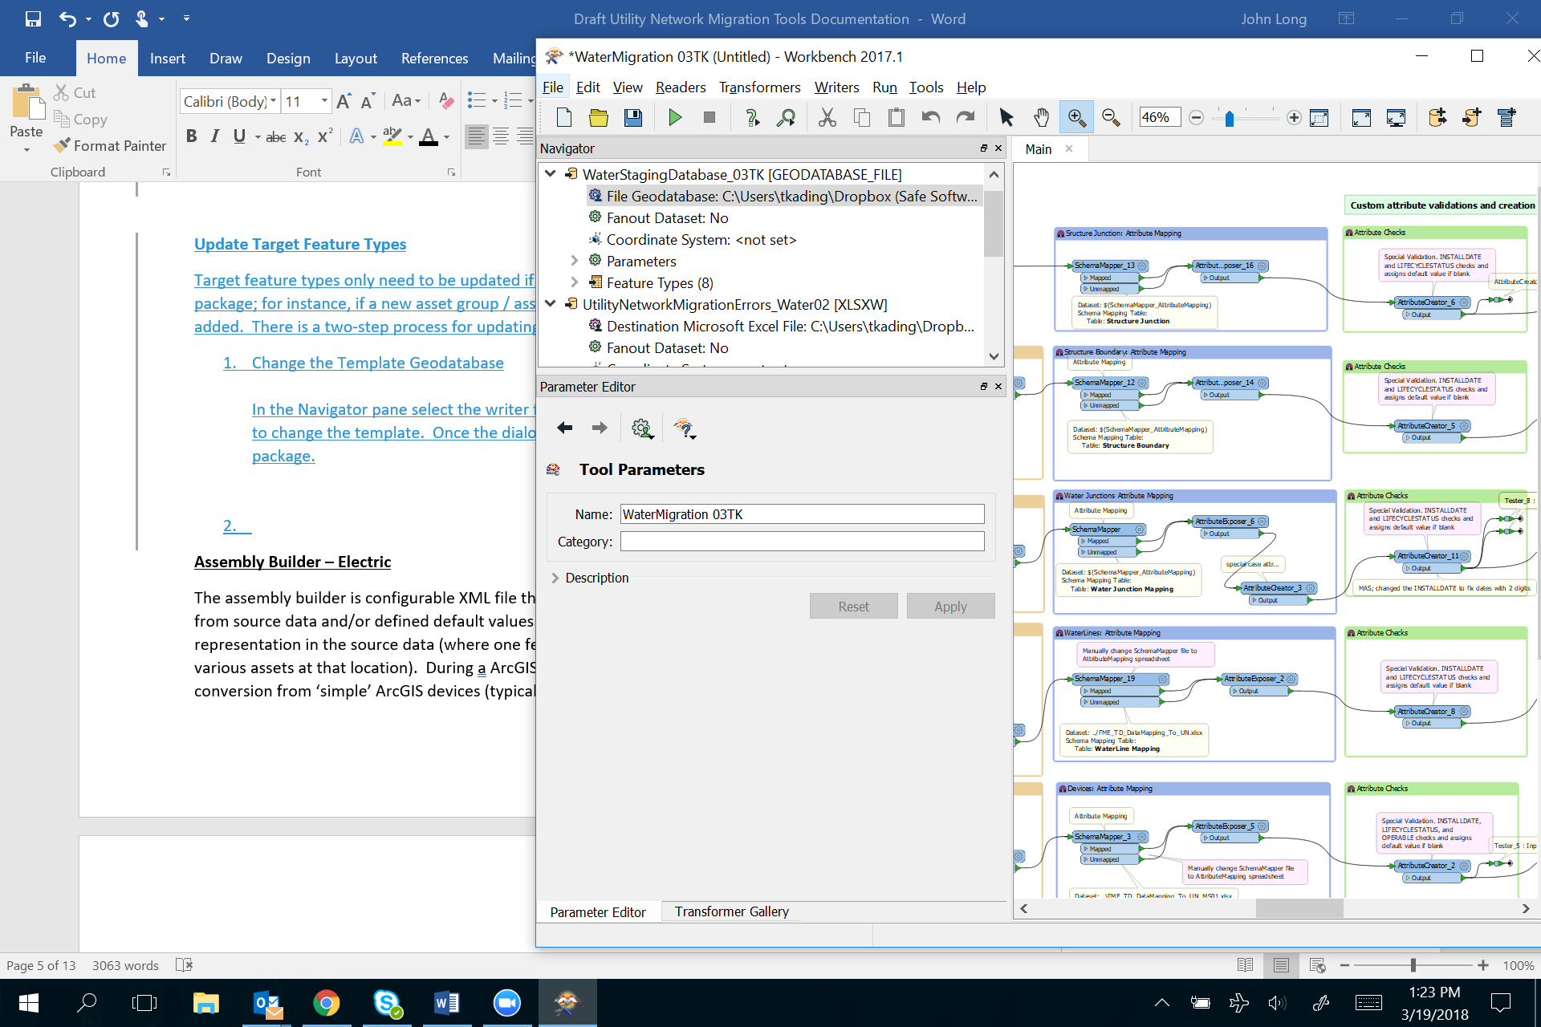

1. Update the Writer—in the “Writer” menu, select “Update Feature Types”. When the dialog pops up, select the template that was just updated in step 1. Once the template is chosen, then another pop-up dialog will appear prompting for the location of the asset package that will be used. Update the location to the modified asset package.

# B_Rules Additions

The asset package is supplied with an example set of rules for association of different objects in the Utility Network. If you have additional rules that need to be added, this can be loaded as part of the migration using the spreadsheet called B_RulesAddition.xlsx.

# Workspace Changes

It may be necessary to make changes to the workspace, depending on your source data. Reasons for making changes to the core part of the workspace are:

* Source data lacks unit tables. The workspace relies on the presence of unit tables that define the key asset in an assembly. I.e. Medium Voltage Transformer / Overhead Single Phase device in a Medium Voltage Transformer Bank assembly. If your source data does not include unit tables, you must add logic to create them.
* UN Feature Class names: UN Feature Class and domain network name are defined in a series of AttributeCreator transformers under the Schema Mapping Bookmarks. If UN feature classes or domain network names change then these will need to be updated:  
  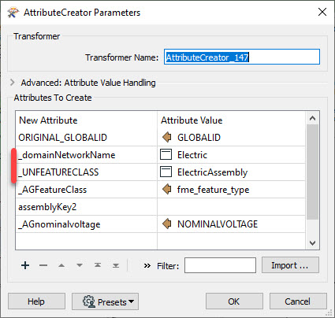

These attribute creators also set some default attribute values used in the migration workspace.

* If there are significant differences between the sample (Naperville) source data model and the new data model, then there may be some other edits required. In the workspace annotations have been added that indicate where schema changes might be needed. Search for SchemaMapping in the workspace search and walk through the annotations.

# Assembly Builder – Electric

The assembly builder is a configurable XML file that defines the patterns or templates used to create assemblies.

The XML defines the following:

* Assembly assetgroup & assettype & assetgroup/type descriptions and relative location (row, column)
* All assets associated with the assembly (assetgroup/type & descriptions) and their relative locations
* All junctions and their relative locations. For junctions the assetgroup/type is obtained from the connected line configuration
* Terminals if required
* Optionally; phase expansion based on the number of phases for the device
* Associations between devices, junctions and internal conductors and structures

**Note**: all locations are a relative location to the assembly insertion point at 0,0. Column is X, Row is Y. Devices are defined horizontally, left to right.

**Primary asset**: The ‘primary’ asset is the asset most closely aligned to the source ArcGIS feature – usually is also associated with a unit table record. This is set by the <keepID> tag. For example, if the ArcGIS device is a Fuse then the ’primary’ asset will likely be the Fuse asset. Attribution and GlobalID are inherited from the ArcGIS unit tables.

**Phase Expansion:** This is where an asset will be cloned based on the number of phases. For example, a two phase fuse will have a single Arrestor definition in the XML, but phaseExpansion will create two clones (one for each phase). Phase attributes are retrieved from the source ArcGIS unit table.

### Assembly Builder XML Format Definition

**Assemblies**: The main tag for the assembly builder XML is <assemblies>. Each individual assembly definition is contained within an <assembly> tag:

<assemblies>

<assembly>

.

.

</assembly>

<assembly>

.

.

</assembly>

</assemblies>

**Assembly**: The assembly definitions contain the assembly <name>, <assetGroupDesc> and <assetTypeDesc> tags, as well as the definitions for each in the assembly:

<assembly>

<name>OH Arrestor</name>

<assemblyGroupDesc></assemblyGroupDesc>

<assemblyTypeConfiguration>

<phasesnormal>1</phasesnormal> # optional: if the

# assemblyTypeDesc

# depends on phase

<assemblyTypeDesc>typeA</assemblyTypeDesc>

</assemblyTypeConfiguration>

<assemblyTypeConfiguration> # repeated for each phase

<phasesnormal>2</phasesnormal>

<assemblyTypeDesc>typeABC</assemblyTypeDesc>

</assemblyTypeConfiguration>

<asset>

.

.

</asset>

<asset>

.

.

</asset>

</assembly>

**AssemblyName**: The <assemblyName> must be unique, since it is used to link the source device in ArcGIS to the Utility Network high fidelity device created for the asset package in the workspace

**Asset group description**s: The <assemblyGroupDesc> should be asset group description that will be assigned to the Assembly point.

**Asset type description:**  <assemblyTypeConfiguration> tags contain the <assemblyTypeDesc> . If the <assemblyTypeDesc> depends on the phase then you may have multiple <assemblyTypeConfiguration> tags, and must include the <phasesnormal> tag.

***Note****: Assemblies do not require a location (row & column - see below). The assembly point is automatically located on the centerline of the highfidelity device, between the first junction and the first asset.*

**Assets**: Each asset in the assembly is defined in the asset definitions. The asset tags include the asset group description, asset type description, Feature Class, location, terminals and associations (links) to other assets in the assembly:

Junctions and assets have slightly different definitions:

**Junction Assets:** Typically, only two junctions per assembly

***Note****: The first junction won’t have a <linkTo> tag as there is no preceding asset.*

*Asset type Description is gathered from the line connections so there is no* <assetTypeDesc> *tag. In most case JN1 will have a row/column of 0,0. The location of the source ArcGIS device*

<asset>

<id>JN2</id> # you can use any ID but we recommend

#JN1 JN2 for junctions

<linkTo> # not on JN1

<id>F1</id>

<fromTerminal>high</fromTerminal>

</linkTo>

<linkTo>

<id>F1</id>

<fromTerminal>high</fromTerminal>

<phaseOffset>-1</phaseOffset>

</linkTo>

<featureClass>ElectricDistributionJunction</featureClass>

<assetGroupDesc></assetGroup> # i.e. Line End

<row>0</row>

<column>3</column>

</asset>

**Device Assets**: any number of assets can be defined. You can use phase expansion to automatically place assets based on the number of phases, or explicitly define each asset in the assembly. The asset tags include the asset group description, asset type description, Feature Class, location, terminals and associations (links) to other assets in the assembly:

<asset>

<id>T1</id>

<linkTo>

<id>F1</id>

<fromTerminal>high</fromTerminal>

</linkTo>

<linkTo>

<id>F1</id>

<fromTerminal>high</fromTerminal>

<phaseOffset>-1</phaseOffset>

</linkTo>

<phaseExpansion>yes</phaseExpansion> # attributes are extracted

# from the ArcGIS unit

# table

<featureClass>ElectricDistributionDevice</featureClass>

<keepID>yes</keepID> # asset type desc , GlobalID

# and attributes are extracted

# from the ArcGIS unit table

<assetGroupDesc></assetGroup>

<assetTypeConfiguration>

<phasesnormal></phasesnormal> # optional: if the

# assetTypeDesc

# depends on phase

<assetTypeDesc></assetType>

</assetTypeConfiguration>

<assetTypeConfiguration> # repeats for each phase

<phasesnormal></phasesnormal>

<assetTypeDesc></assetType>

</assetTypeConfiguration>

<row>0</row>

<column>3</column>

</asset>

**Asset Feature class:** The asset <featureClass>, usually ElectricDevice or ElectricJunction for junction assets

**Asset Group Description**: <assetGroupDesc> always required

**Asset type description:** <assetTypeConfiguration> tags contain the <assetTypeDesc> . If the <assetTypeDesc> depends on the phase then you may have multiple <assetTypeConfiguration> tags, and must include the <phasesnormal> tag.

<assetTypeDesc> will be overwritten on the primary device (<keepID>) by the source ArcGIS unit table asset type descriptions.

**Location**: The <row> (Y) and <column> (X) tags are used to locate each asset within the assembly. These are relative locations to the assembly insertion point at row 0, column 0. Devices should normally be arranged horizontally in order from left to right.

**Phase Expansion**: The <phaseExpansion> tag allows you to choose whether the asset will be cloned into separate assets for each phase, by creating additional rows above and below the device in that column. By using phase expansion, you can create a single definition for single and multiphase devices, letting the input phasing determine the number of devices in a bank. If you use phase expansion, you must take care that there are no other devices in the rows above and below the expanded device. The allowable values are yes and no, with no being the default if the tag is not present.

Phase expansion enables the allocation of attributes (typically phasesnormal) from the source ArcGIS unit tables.

Phase expansion will create a separate association for each phase from the <linkTo> tags. When linking to another phase expanded device, the association will be created to the device with the same phase. However, if the <phaseOffset> tag is present in the link, the association will link to the offset phase. For example an offset of -1 will link phase A to C, B to A and C to B, while an offset of 1 will link A to B, B to C and C to A. <phaseOffset> = 0 (default) will link phase A to A etc.

**Associations**: The <id> and <linkTo> tags control the associations between the devices within the <assembly>. The linkage should be defined on the To device, with the <linkTo> containing the <id> of the From device. There can be multiple links on a device. The <linkTo> tag links to the previous device in the assembly definition. You can use any value for , <id> but we recommend simple abbreviations, i.e.

* JN1 JN2 for junctions
* AR1 for arrestors
* F1 for fuses
* T1 transformers
* etc.

The <id> must be unique each asset in a given assembly

**Phases Offset:** Optional tag in the <linkTo> tag. By default the associations are linear through the assembly for a single phase. For cross phase associations include the <phaseOffset> tag. <phaseOffset> is used in phase expansion and is used for devices where the phases link across to another phase, such as a overhead 3 phase Delta transformer. Typical values will be -1, 0 , 1. (0 is the default)

**Terminals**: Optional tag in the <linkTo> tag. The link <fromTerminal> and <toTerminal> tags are used to populate attributes on the Association features that are also produced by the device (usually a transformer). If this is not set, the attribute will be set to Single Terminal. Currently used values are:

* High and low for transformers
* Source and Load for arrestors

**GlobalID:** GlobalID is preserved for the Assembly (from the ArcGIS source device ).

GlobalIDs for the ‘primary’ device (<keepID>) are preserved from the ArcGIS unit tables. The primary device is defined in the XML definition by the <keepID> tag. If the tag is present and set to yes on a device, that device will be given the unit table GlobalIDs. There should be only one device in the assembly with a <keepID> set to yes. The Asset Type Description will also be gathered from the unit tables

Unit Table Attributes: Unit table attributes (usually globalid & phasesnormal) are preserved on assets with phase expansion

# Running the Migration Workspace

The workspace is designed to be run in prompt-mode to help minimize configuration issues. To ensure your workspace is running in prompt mode, select the “Set Workbench to Prompt Before Running” button.



By selecting this button, the workspace will prompt the user for configuration parameters:

* Location of “Target Asset Package File Geodatabase”
* Location of “Data Error Excel File”
* Location of “Schema Mapper Excel File”
* Location of “File Geodatabase Template (.gdb)”
* Location of “Error File Geodatabase”
* “What is the name of the Laterals Feature Class”
* “What is the name of the Water Mains Feature Class”
* Location of “Source Geodatabase”

|  |  |
| --- | --- |
|  | Parameters will vary depending on the domain (gas, water, electric). |

Press the “Run Translation” button 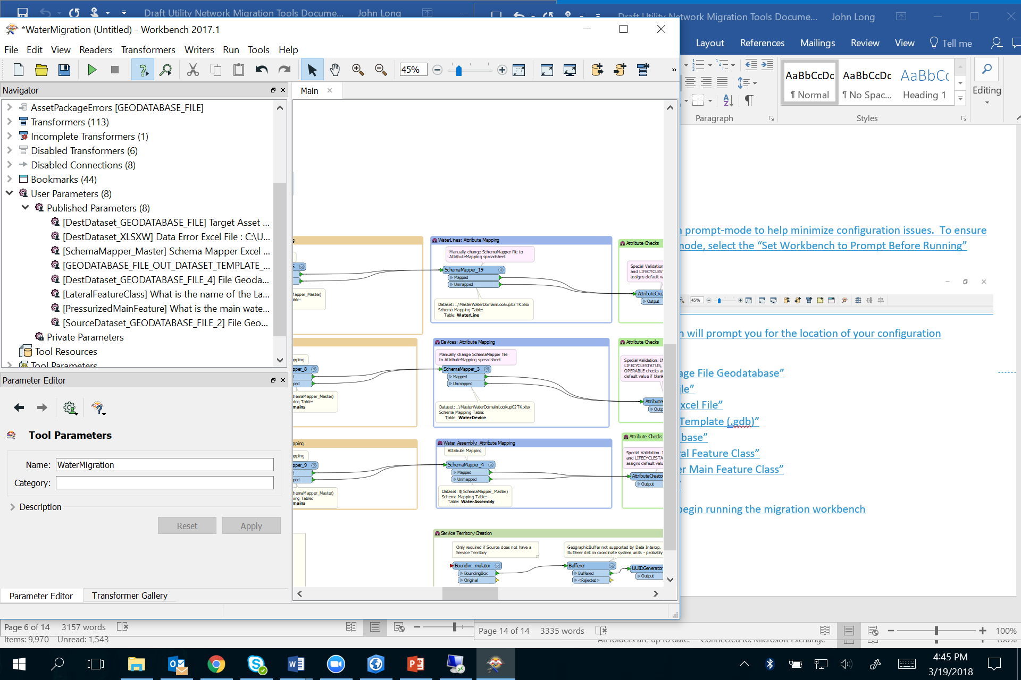 to begin running the migration workspace.

# Applying the Asset Package to a Utility Network

It is time to continue on with where we left off in our Electric Utility Network Configuration: “[Apply the asset package](http://solutions.arcgis.com/electric/help/electric-utility-network-configuration/get-started/create-electric-utility-network.htm#GUID-45EC17EC-5A6C-471A-916B-91FB211F42E7)”. The following information provides a different perspective of the steps as well as additional context around the migration of the sample data.

Once the data has been migrated to the staging asset package, the asset package will need to be applied to the utility network that was staged. Using the ArcGIS Solutions’ “Apply Asset Package” tool:

* Add the location of the staging asset package
* Select the domains that will be applied
* Define the target utility network the asset package will be applied to
* Select “Load Data” and “Calculate Spatial Index and Analyze”

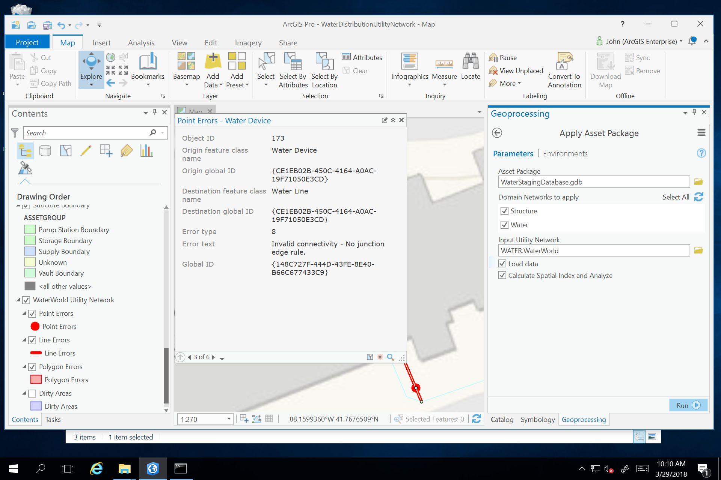

This will load the staging asset package to the target utility network.

|  |  |
| --- | --- |
|  | When applying the asset package to the utility network, the files used to apply the properties of the asset package are written to the “AP workspace” folder; such as the associations and rules. |

With the asset package applied to the utility network, run the “Enable Topology” geoprocessing tool. By selecting the “Only generate errors” option, you can validate the quality and suitability of the migration for the utility network.

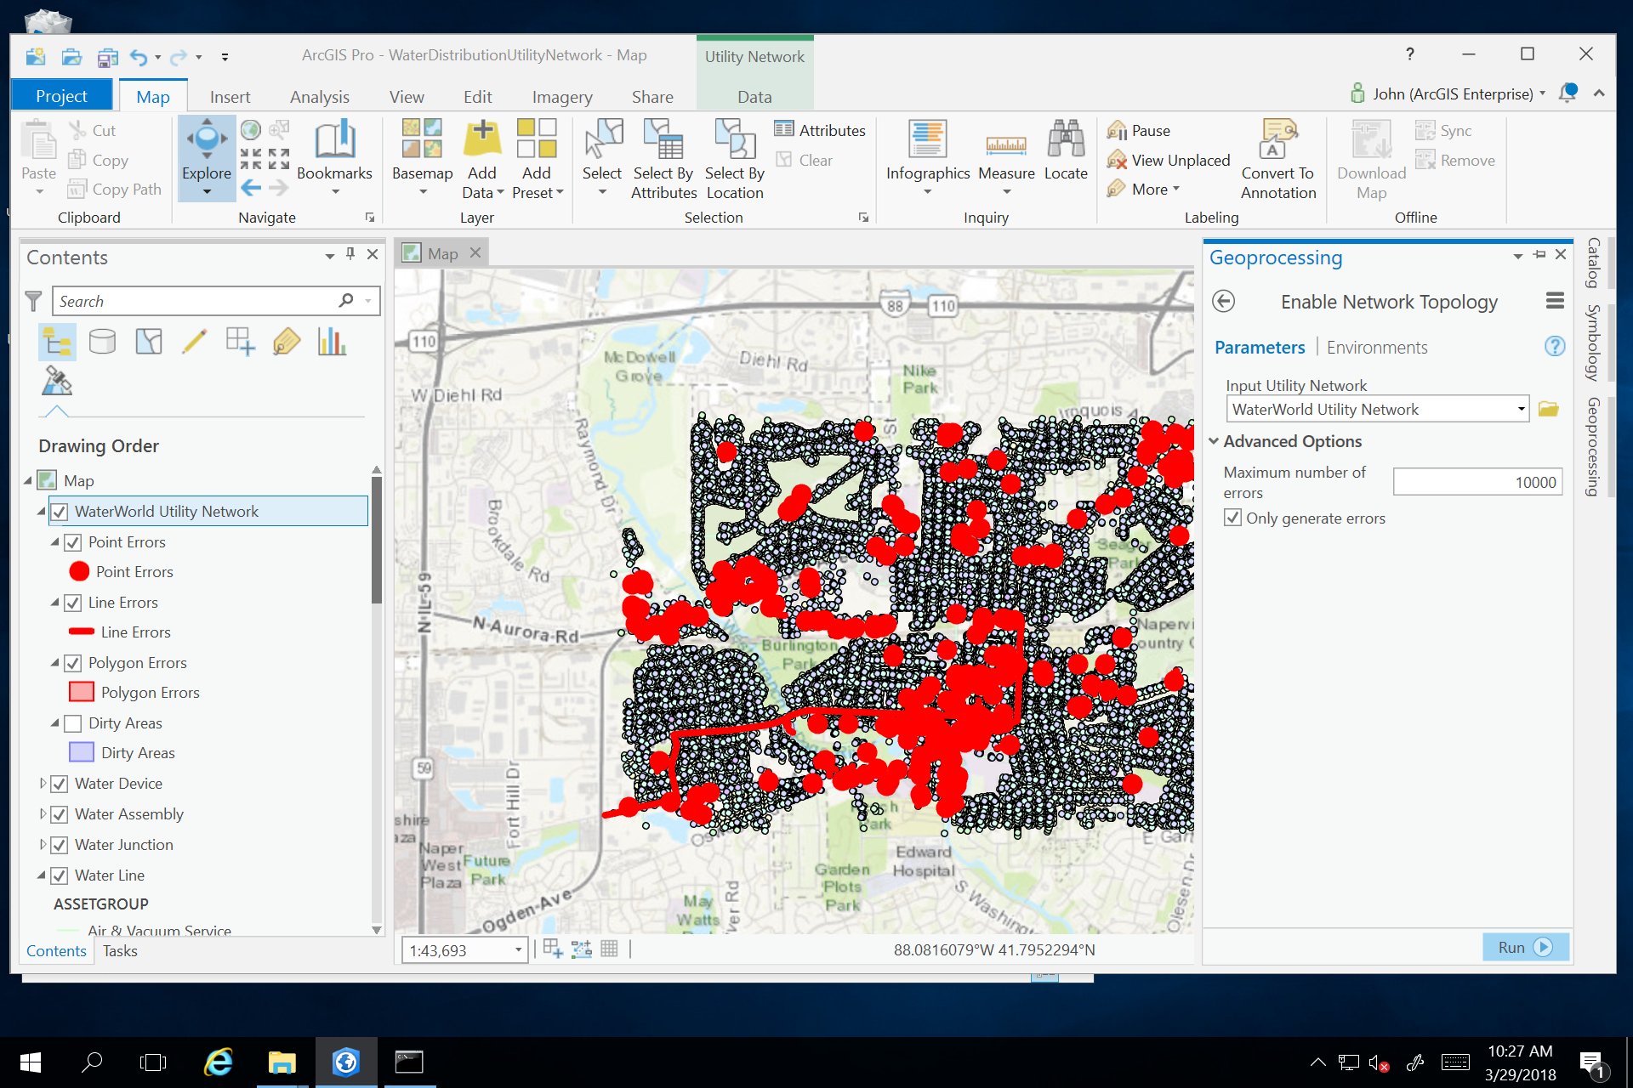

At this stage, the topology errors identify distinct items that you may need to reconsider:

* Data mapping issues in the schema mapper that result in rule violations
* Bad data that result in rule violations:
  + Stacked features
* Utility network rules that need to be updated to support data

|  |  |
| --- | --- |
|  | The sample staging asset package and the migration tools themselves have mappings that result in some of the errors described above. This is by design to familiarize you with:   * + Data quality issues   + Importance of understanding your source data and the target asset package   + Importance of data mapping   + Understanding utility network rules |

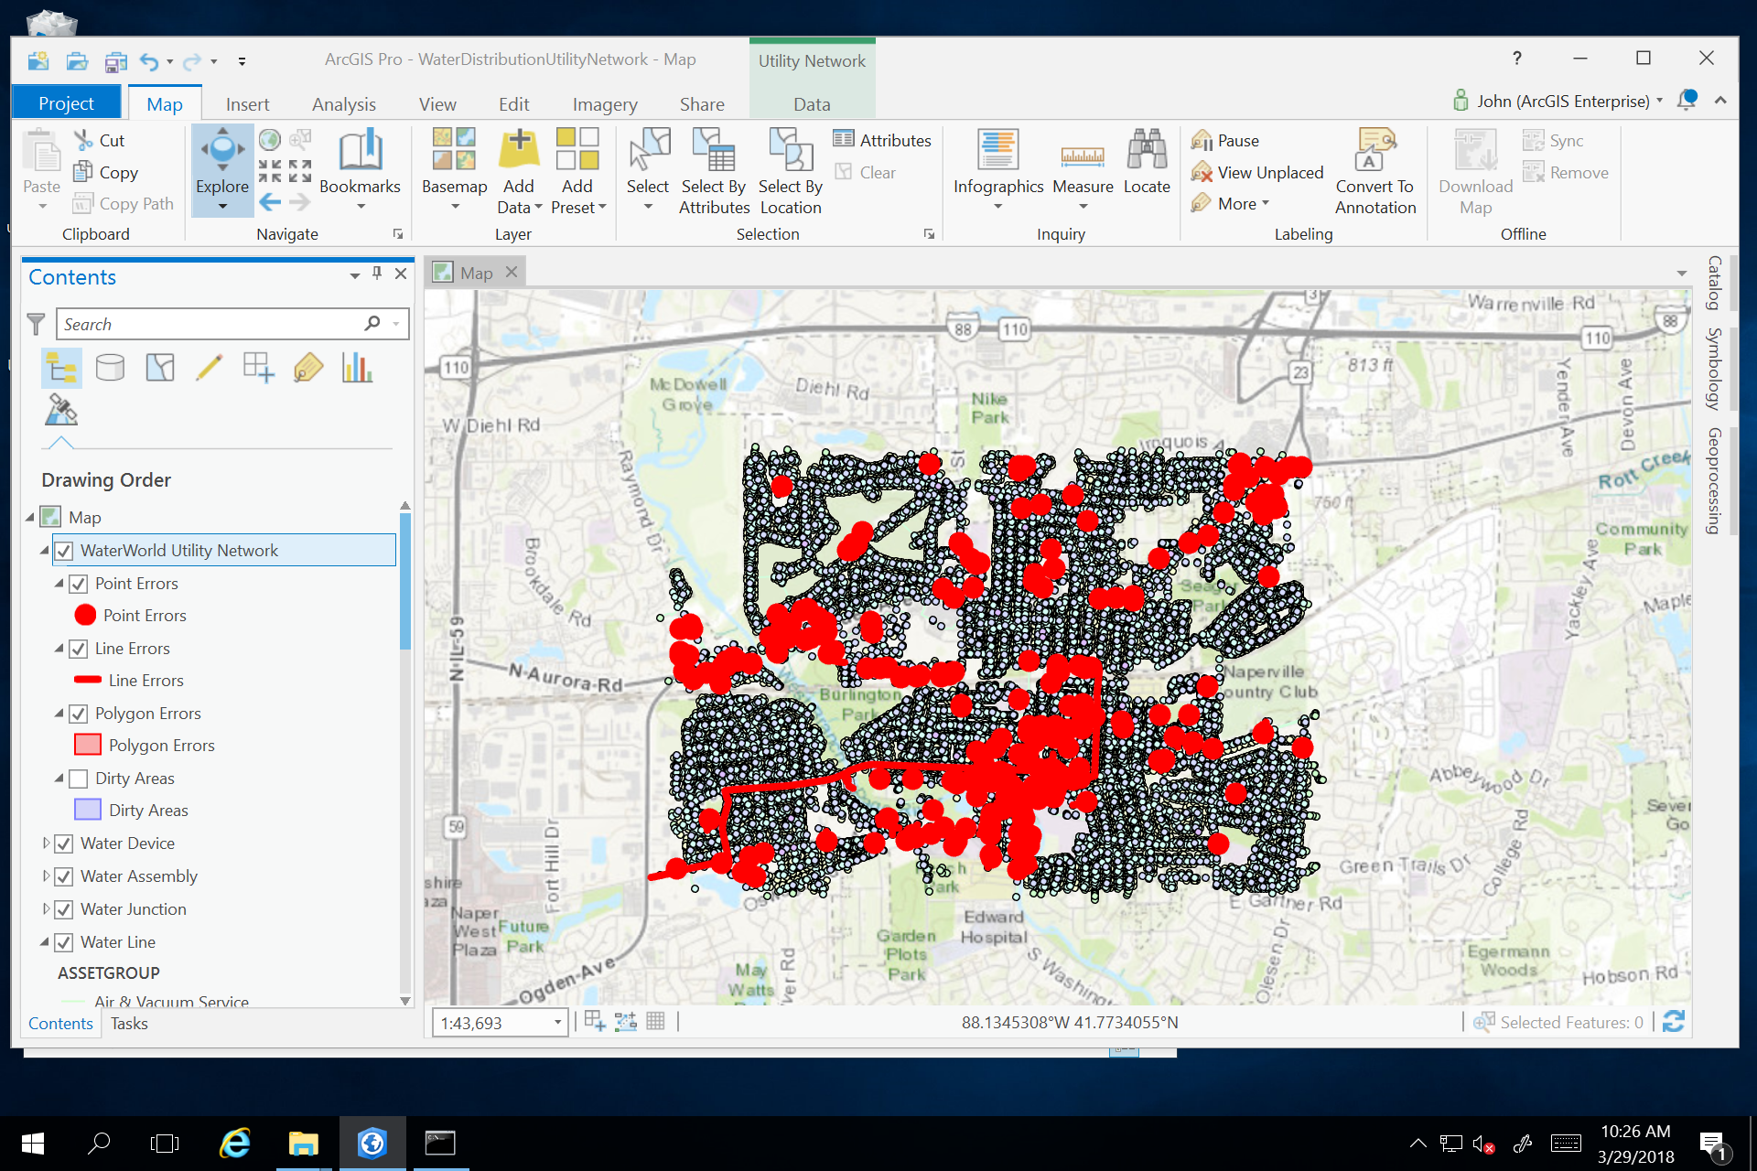

The errors in the staging asset package can be resolved in one of several ways:

* Update the rules in the utility network
* Update the schema mapper spreadsheet by mapping to actual devices rather than “Unknown”
* Resolve data issues in the source data

|  |  |
| --- | --- |
|  | After loading your own data you will need perform additional edits to create associations between features and assign features as controllers for your subnetworks. |